1. What is the ip address of your wireless card?

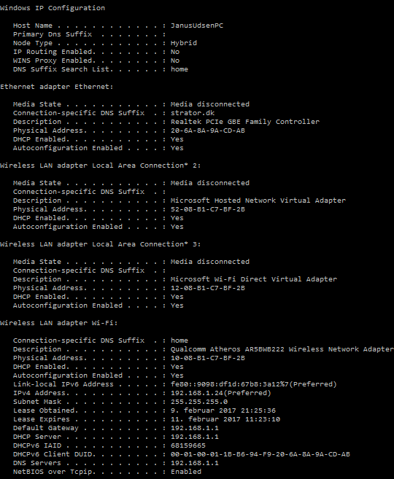

192.168.1.24

1. What is the DNS server address?

192.168.1.1

1. What is the MAC address?

12-08-B1-C7-BF-2B

1. How many network interfaces do you have?

4

1. Why do you have more than one? What are they for?

Fordi min computer har flere måder at connecte på og derfor har jeg flere, et interface er bare en connection mellem 2 ting. Flere ting jeg kan connecte igennem.